**Item Management**

**Item Management** is an application to **manage item** for sale. You as a programmer are asked to build this application. Use **Double Linked List concept** to make this application. There will be **3 menus** in this application:

1. **Add Product**
2. **Sale Product**
3. **Exit**

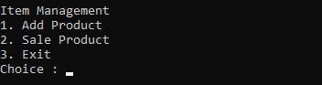

**Before print the menu**, the application will **print all data in the linked list**, if there is no data then don’t need to print anything.

1. **Add Product**

If user choose this menu then the application will ask input for Item Name, Price and Quantity. **Validate** Item Name **must start with “Item “.**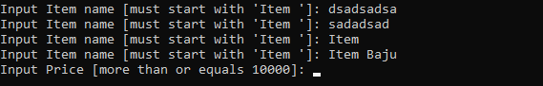

**Validate** Item name must be **lower case.**



**Validate** Price must be **greater than 10000**.

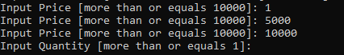

**Validate** Quantity **more than or equals 1.**



Then **push** the data into linked list. **Use Priority Queue** depends on Item Name (Ascending)

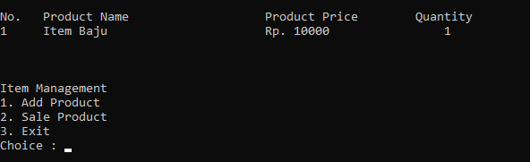

1. **Sale Product**

If user choose this menu,

**Validate** is the linked list **empty or not**. If empty show error message.

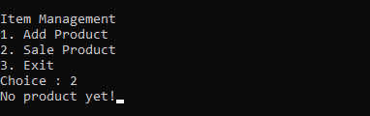

Then the application will ask input for Item name to search. **Validate** Item name **must be in the linked list**.

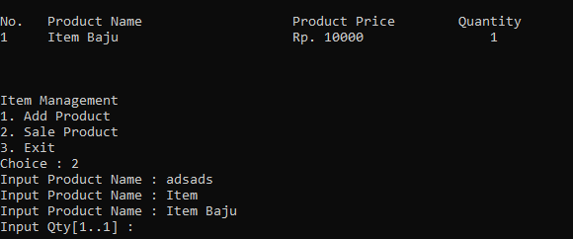

Then the application will ask input for Qty. **Validate** Qty **must be less than or equals** Quantity of the product.



Then change the Quantity of the product in the linked list by this formula.

**Quantity = Quantity – Qty.**

If Quantity of product is 0 then **pop** the Product.

**Please run the exe for more information.**